Ex.no:6c | DATA VISUALIZATION USING POWER BI  (GLOBAL EARTHQUAKE PREDICTION)

Aim:
To clean, preprocess, and transform the raw Global Earthquake Analysis dataset, load the cleaned data into Power BI, and build an interactive visual dashboard to analyze earthquake frequency, magnitude, depth, geographical distribution, magnitude types, and earthquake activity patterns over time.
Algorithm:
- Import Dataset: Load Global_Earthquake_Analysis.csv into the environment.
- Deduplication: Identify and delete duplicate earthquake records across all fields.
- Remove Blank Rows: Identify and remove completely blank records from the dataset.
- Handle Missing Values: Identify missing values in each column and replace or remove them appropriately to maintain data consistency.
- Handle Data Type Errors: Convert numerical attributes such as Latitude, Longitude, Depth, and Magnitude into appropriate numerical data types. Convert Date into the appropriate date format.
- Clean Text Data: Remove unnecessary spaces and standardize categorical values such as Magnitude_Type and other location-related categorical fields where required.
- Create Magnitude Categories: Categorize earthquakes based on their magnitude values into groups such as Minor, Moderate, Strong, Major, and Great to support meaningful analysis and visualization.
- Create Depth Categories: Categorize earthquake depths into Shallow, Intermediate, and Deep categories to analyze the distribution of earthquakes based on depth.
- Create Year Attribute: Extract the year from the Date field to analyze earthquake activity and trends over time.
- Load Clean Data: Load the cleaned Global Earthquake dataset into Power BI Desktop using Get Data → Text/CSV and select Transform Data if further cleaning is required.
- Create Core Metrics: Create measures in Power BI to calculate important earthquake metrics.

Output:
1.BAR CHART
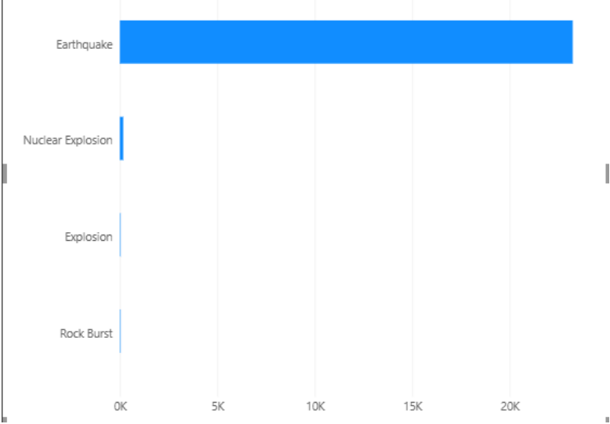
2.Column Chart
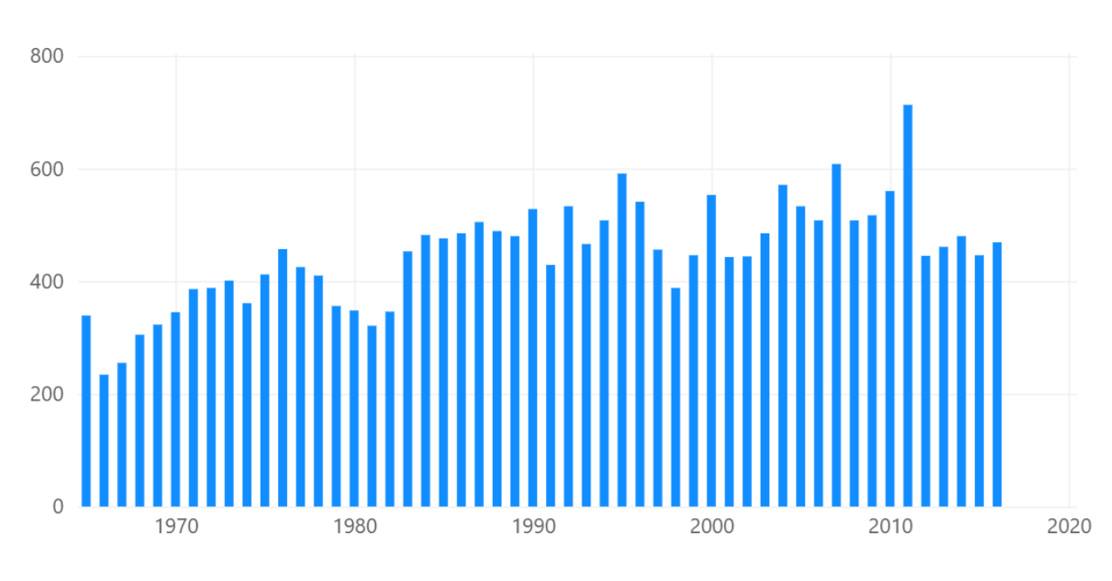

3.Donut Chart
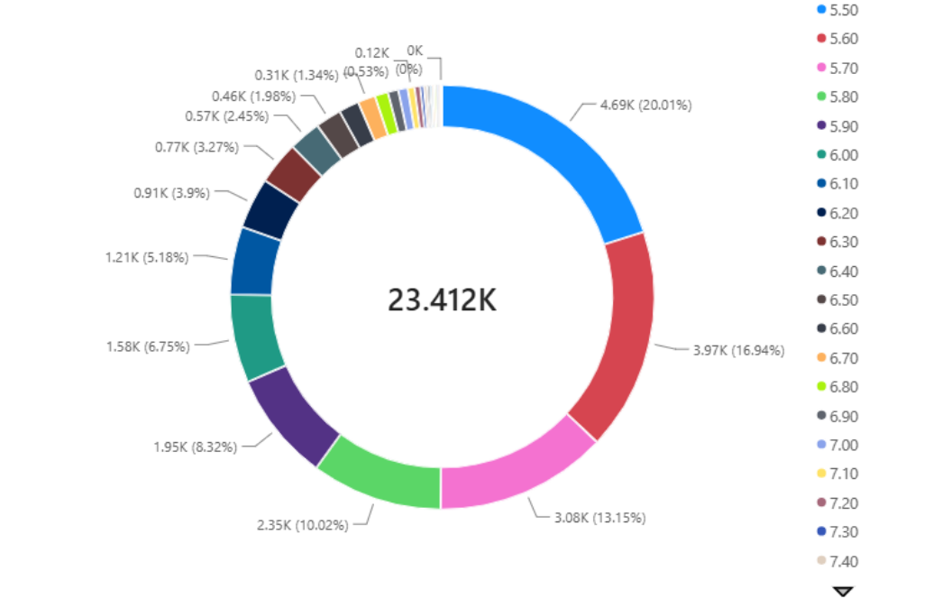
4.KPI CARD
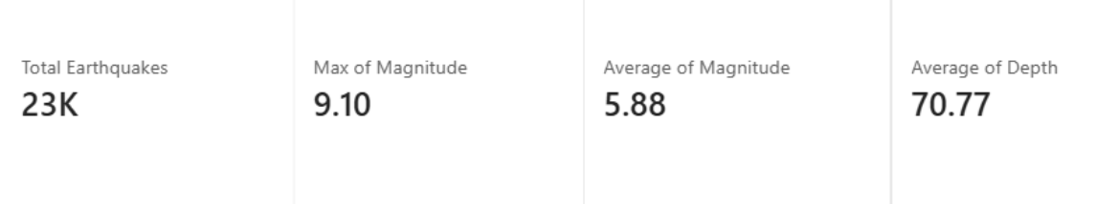
5.Line Chart
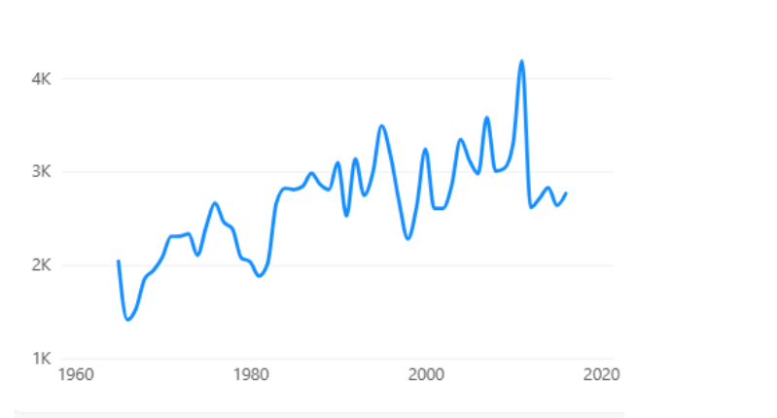

Result:

